MAHARASHTRA STATE BOARD OF TECHNICAL EDUCATION,

**MUMBAI**

Shri Vishweshwar Shikshan Prasarak Mandal’s

Vishweshwarayya Abhiyantriki Padvika Mahavidhyalaya,

Almala

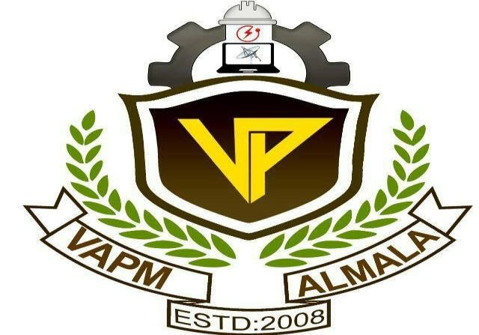

# Certificate

This is to certify that **Mashale Soham Kiran, Patel Riyan Mahmmadrasul, Swami Malhar Sanjivkumar, Kore Vaibhav Nagnath, Gavhale Aniket Nagnath** students of our institute from **First** year **Computer Engineering (CO2I)** have successfully completed the micro project report on “Personal Appearance and Grooming Tips” of course **“BCC(22009)”** as part of curriculum by the Maharashtra State Board of Technical Education, Mumbai.

For partial fulfillment of “Diploma in Computer Engineering” during the academic year 2022-2023.

GUIDE HOD

Mrs. Padule R. V. Mr. Kazi A.S.M.

PRINCIPAL

Mr. Dharashive P.S.

**MAHARASHTRA STATE BOARD OF TECHNICAL EDUCATION,**

**MUMBAI**

Shri Vishweshwar Shikshan Prasarak Mandal’s

Vishweshwarayya Abhiyantriki Padvika Mahavidhyalaya,

Almala

Micro-Project Report On

Personal Appearance and Grooming Tips

Submitted By

Enrollment No Name of Student

2210950166 Mr. Mashale Soham Kiran

2210950173 Mr. Patel Riyan mahmmadrasul

2210950172 Mr. Swami Malhar Sanjivkumar

2210950157 Mr. Kore Vaibhav Nagnath

2210950161 Mr. Gavhale Aniket Nagnath

Under the Guidance of

Mrs. Padule R. V.



Department of Computer Engineering

Academic Year 2022-23